**109 Commonly Asked Data Science Interview Questions**

https://secure.gravatar.com/avatar/8e881879b5ee7e2f4f2aba8f5afa642a?s=50&d=mm&r=g

Michael Rundell



* 1
* 6
* 4
* 2
* 1

A Curated List of Data Science Interview Questions

Preparing for an interview is not easy – naturally there is a large amount of uncertainty regarding the data science interview questions you will be asked. No matter how much work experience or technical skill you have, an interviewer can throw you off with a set of questions that you didn’t expect. For a data science interview, an interviewer will ask questions spanning a wide range of topics, requiring strong technical knowledge and communication skills from the part of the interviewee. Your statistics, programming, and data modeling skills will be put to the test through a variety of questions and question styles – intentionally designed to keep you on your feet and force you to demonstrate how you operate under pressure. Preparation is a major key to success when in pursuit of a [career in data science](https://www.springboard.com/workshops/data-science-career-track/).

This guide contains all of the data science interview questions an interviewee should expect when interviewing for a position as a data scientist. At [Springboard](http://springboard.com/), we teach data science through our [mentored data science workshops](https://www.springboard.com/workshops/data-science-intensive). They’re a great way to learn data science and get expert guidance on [how to get a data science job](https://www.springboard.com/resources/guide-to-data-science-jobs). We did our due diligence to comb through the internet to find real questions asked to data science interview candidates. We had built a [data science interview guide](https://www.springboard.com/resources/data-scientist-interview-guide), yet we still felt we had more to explore.

We set off to curate, create and edit different data science interview questions and provided answers for some. From this list of **data science interview questions**, an interviewee should be able to prepare for the tough questions, learn what answers will positively resonate with an employer, and develop the confidence to ace the interview. We’ve broken the data science interview questions into six different categories: statistics, programming, modeling, behavior, culture, and problem-solving.

**Table of Contents**

1. [**Statistics**](https://www.springboard.com/blog/data-science-interview-questions/#statistics)
2. [**Programming**](https://www.springboard.com/blog/data-science-interview-questions/#programming)
   1. *General*
   2. *Big Data*
   3. *Python*
   4. *R*
   5. *SQL*
3. [Modeling](https://www.springboard.com/blog/data-science-interview-questions/#modeling)
4. [**Behavioral**](https://www.springboard.com/blog/data-science-interview-questions/#behavioral)
5. [**Culture Fit**](https://www.springboard.com/blog/data-science-interview-questions/#culture)
6. [**Problem-Solving**](https://www.springboard.com/blog/data-science-interview-questions/#problem)

1. Statistics

Statistical computing is the process through which data scientists take raw data and create predictions and models backed by the data. Without an advanced knowledge of statistics it is difficult to succeed as a data scientist – accordingly it is likely a good interviewer will try to probe your understanding of the subject matter with statistics-oriented data science interview questions. Be prepared to answer some fundamental statistics questions as part of your data science interview.

Here are examples of rudimentary statistics questions we’ve found:

1. What is the Central Limit Theorem and why is it important?
   * [*Answer*](https://spin.atomicobject.com/2015/02/12/central-limit-theorem-intro/)
2. What is sampling? How many sampling methods do you know?
3. What is the difference between Type I vs Type II error?
4. What is linear regression? What do the terms P-value, coefficient, R-Squared value mean? What is the significance of each of these components?
   * [*Answer*](http://www.statisticssolutions.com/assumptions-of-linear-regression/)*,*[*Answer*](http://blog.minitab.com/blog/adventures-in-statistics/how-to-interpret-regression-analysis-results-p-values-and-coefficients)
5. What are the assumptions required for linear regression?
   * *There are four major assumptions: 1. There is a linear relationship between the dependent variables and the regressors, meaning the model you are creating actually fits the data, 2. The errors or residuals of the data are normally distributed and independent from each other, 3. There is minimal multicollinearity between explanatory variables, and 4. Homoscedasticity. This means the variance around the regression line is the same for all values of the predictor variable.*
6. What is a statistical interaction?
   * [*Answer*](http://icbseverywhere.com/blog/mini-lessons-tutorials-and-support-pages/statistical-interactions/)
7. What is selection bias?
8. What is an example of a dataset with a non-Gaussian distribution?
9. What is the Binomial Probability Formula?

*Examples of similar data science interview questions found from Glassdoor:*

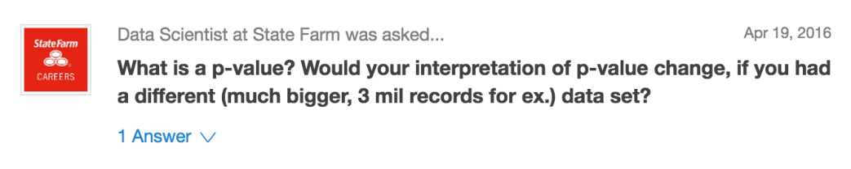

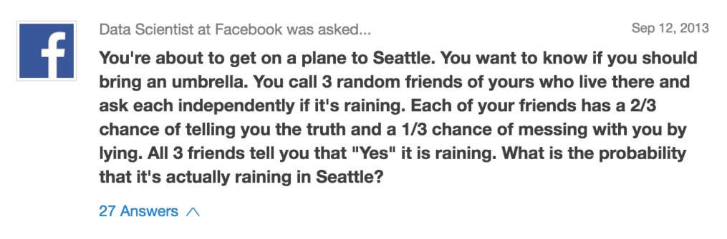

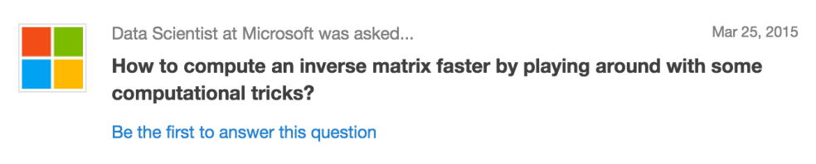

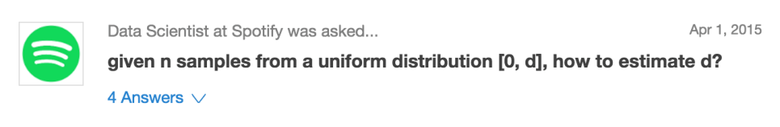

2. Programming

To test your programming skills, employers will ask two things during their data science interview questions: they’ll ask how you would solve programming problems in theory without writing out the code, and then they will also offer whiteboarding exercises for you to code on the spot. For the latter types of questions we will cover a few examples below, but if you’re looking for in-depth practice solving coding challenges, visit [Interview Cake](https://www.interviewcake.com/all-questions/python). They have an in-browser module for typing code, and they can walk you through tricky problems – all absolutely free.

2.1 *General*

1. With which programming languages and environments are you most comfortable working?
2. What are some pros and cons about your favorite statistical software?
3. Tell me about an original algorithm you’ve created.
4. Describe a data science project  in which you worked with a substantial programming component. What did you learn from that experience?
5. Do you contribute to any open source projects?
6. How would you clean a dataset in (insert language here)?
7. Tell me about the coding you did during your last project?

2.2 *Big Data*

1. What are the two main components of the Hadoop Framework?
2. Explain how MapReduce works as simply as possible.
   * [*Answer*](http://stackoverflow.com/questions/28982/simple-explanation-of-mapreduce)
3. How would you sort a large list of numbers?
4. Here is a big dataset. What is your plan for dealing with outliers? How about missing values? How about transformations?

2.3 *Python*

1. What modules/libraries are you most familiar with? What do you like or dislike about them?
2. What are the supported data types in Python?
3. What is the difference between a tuple and a list in Python?

For additional Python questions that focus on looking at specific snippets of code, check out this useful [resource created by Toptal](https://www.toptal.com/python/interview-questions).

2.4 *R*

1. What are the different types of sorting algorithms available in R language?
   * *There are insertion, bubble, and selection sorting algorithms.*
2. What are the different data objects in R?
3. What packages are you most familiar with? What do you like or dislike about them?
4. How do you access the element in the 2nd column and 4th row of a matrix named M?
5. What is the command used to store R objects in a file?
6. What is the best way to use Hadoop and R together for analysis?
7. How do you split a continuous variable into different groups/ranks in R?
8. Write a function in R language to replace the missing value in a vector with the mean of that vector.

2.5 *SQL*

Often, SQL questions are case-based, meaning that an employer will task you with solving an SQL problem in order to test your skills from a practical standpoint. For example, you could be given a table and be asked to extract relevant data, filter and order the data as you see fit, and report your findings. If you do not feel ready to do this in an interview setting, [Mode Analytics](https://community.modeanalytics.com/sql/tutorial/introduction-to-sql/) has a delightful introduction to using SQL that will teach you these commands through an interactive SQL environment.

1. What is the purpose of the group functions in SQL? Give some examples of group functions.
2. Group functions are necessary to get summary statistics of a dataset. COUNT, MAX, MIN, AVG, SUM, and DISTINCT are all group functions
3. Tell me the difference between an inner join, left join/right join, and union.
   * [*Answer*](https://www.quora.com/SQL-What-is-the-difference-between-inner-join-left-join-right-join-and-full-join)
4. What does UNION do? What is the difference between UNION and UNION ALL?
5. What is the difference between SQL and MySQL or SQL Server?
6. If a table contains duplicate rows, does a query result display the duplicate values by default? How can you eliminate duplicate rows from a query result?

For additional SQL questions that focus on looking at specific snippets of code, check out this useful [resource created by Toptal](https://www.toptal.com/sql/interview-questions).

*Examples of similar data science interview questions found from Glassdoor:*

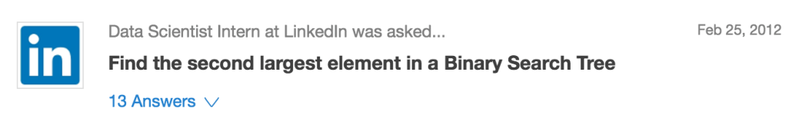

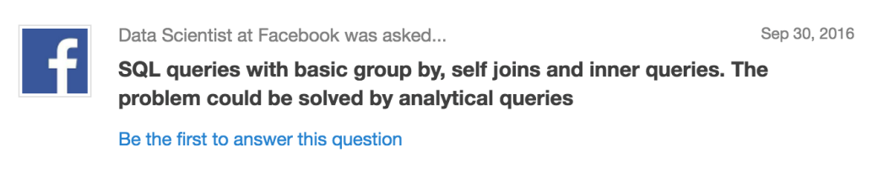

3. Modeling

Data modeling is where a data scientist provides value for a company. Turning data into predictive and actionable information is difficult, talking about it to a potential employer even more so. Practice describing your past experiences building models – what were the techniques used, challenges overcome, and successes achieved in the process? The group of questions below are designed to uncover that information, as well as your formal education of different modeling techniques. If you can’t describe the theory and assumptions associated with a model you’ve used, it won’t leave a good impression.

Take a look at the questions below to practice. Not all of the questions will be relevant to your interview – you’re not expected to be a master of all techniques. The best use of these questions is to re-familiarize yourself with the modeling techniques you’ve learned in the past.

1. Tell me about how you designed the model you created for a past employer or client.
2. What are your favorite data visualization techniques?
3. How would you effectively represent data with 5 dimensions?
4. How is kNN different from k-means clustering?
   * *kNN, or k-nearest neighbors is a classification algorithm, where the k is an integer describing the the number of neighboring data points that influence the classification of a given observation. K-means is a clustering algorithm, where the k is an integer describing the number of clusters to be created from the given data. Both accomplish different tasks.*
5. How would you create a logistic regression model?
6. Have you used a time series model? Do you understand cross-correlations with time lags?
7. Explain the 80/20 rule, and tell me about its importance in model validation.
8. Explain what precision and recall are. How do they relate to the ROC curve?
   * [*Answer*](http://www.kdnuggets.com/faq/precision-recall.html)*. Recall describes what percentage of true positives are described as positive by the model. Precision describes what percent of positive predictions were correct. The ROC curve shows the relationship between model recall and specificity – specificity being a measure of the percent of true negatives being described as negative by the model. Recall, precision, and the ROC are measures used to identify how useful a given classification model is.*
9. Explain the difference between L1 and L2 regularization methods.
10. What is root cause analysis?
11. What are hash table collisions?
12. What is an exact test?
13. In your opinion, which is more important when designing a machine learning model: Model performance? Or model accuracy?
    * [*One approach to this question*](https://en.wikipedia.org/wiki/Accuracy_paradox)
14. What is one way that you would handle an imbalanced dataset that’s being used for prediction? (i.e. vastly more negative classes than positive classes.)
15. How would you validate a model you created to generate a predictive model of a quantitative outcome variable using multiple regression?
16. I have two models of comparable accuracy and computational performance. Which one should I choose for production and why?
17. How do you deal with sparsity?
18. Is it better to spend 5 days developing a 90% accurate solution, or 10 days for 100% accuracy?
19. What are some situations where a general linear model fails?
20. Do you think 50 small decision trees are better than a large one? Why?
21. When modifying an algorithm, how do you know that your changes are an improvement over not doing anything?
22. Is it better to have too many false positives, or too many false negatives?

*Examples of similar data science interview questions found from Glassdoor:*

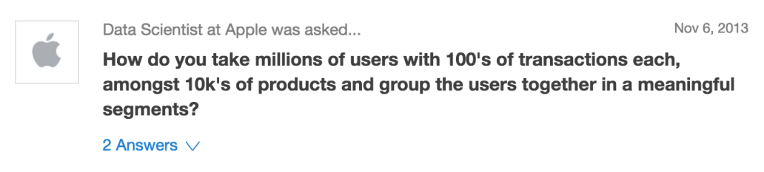

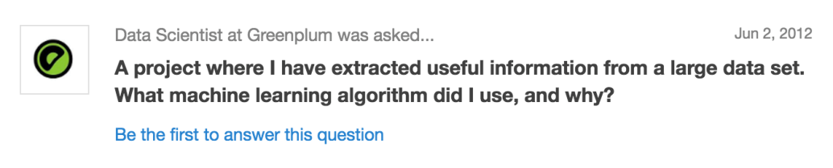





4. Past Behavior

Employers love behavioral questions. They reveal information about the work experience of the interviewee as well as information about the demeanor of any potential team member. From these questions, an interviewer wants to see how a candidate has reacted to situations in the past, how well they can articulate what their role was, and what they learned from their experience.

There are several categories of behavioral questions you’ll be asked:

1. Teamwork
2. Leadership
3. Conflict Management
4. Problem-solving
5. Failure

Before the interview, write down examples of work experience related to these topics to refresh your memory – you will need to recall specific examples to answer the questions. When asked about a prior experience, make sure you tell a story as well. Being able to concisely and logically craft a story to detail your experiences is important. For example – ”I was asked X, I did A, B, and C, and decided that the answer is Y”.

Of course, if you can highlight experiences having to do with data science, these questions present a great opportunity to showcase a unique accomplishment as a data scientist that you may not have discussed previously.

Here are examples of these sorts of questions:

1. Tell me about a time when you took initiative.
2. Tell me about a time where you had to overcome a dilemma.
3. Tell me about a time where you resolved a conflict.
4. Tell me about a time you failed, and what you have learned from it.
5. Tell me about (a job on your resume). Why did you choose to do it and what do you like most about it?
6. Tell me about a challenge you have overcome while working on a group project.
7. When you encounter a tedious, boring task, how would you deal with it and motivate yourself to complete it?
8. What have you done in the past to make a client satisfied/happy?
9. What have you done in your previous job that you are really proud of?
10. What do you do when your personal life is running over into your work life?

*Examples of similar data science interview questions found from Glassdoor:*

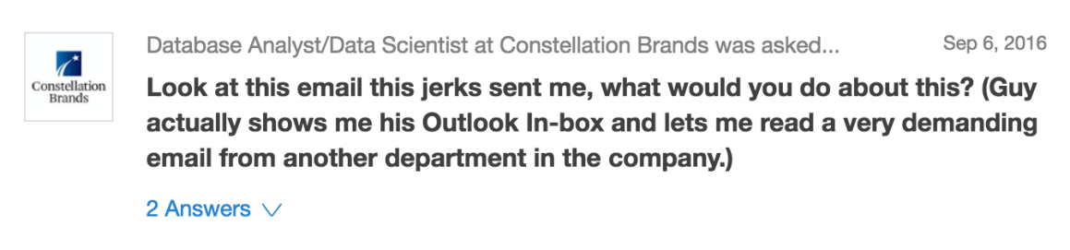

5. Culture

If an employer asks you a question on this list, they are trying to get a sense of who you are and how you would fit with the company. They’re trying to gauge where your interest in data science and the hiring company come from. Take a look at these examples and think about what your best answer would be, but keep in mind – it’s important to be honest with these questions. There’s no reason to not be yourself. There are no right answers to these questions – but the best answers are communicated with confidence and a smile.

1. Which data scientists do you admire most? Which startups?
   * *There are plenty of amazing data scientists to choose from – take a look at*[*this article*](https://www.springboard.com/blog/top-data-scientists-on-twitter/)*on top data science influencers for some more insight on some of the top data scientists in the world.*
2. What do you think makes a good data scientist?
3. How did you become interested in data science?
4. Give a few examples of “best practices” in data science.
5. What/when is the latest data science book / article you read? What/when is the latest data mining conference / webinar / class / workshop / training you attended?
   * *If you haven’t read a good data science book recently, Springboard compiled*[*a list of the best data science books to read*](https://www.springboard.com/blog/eleven-best-data-science-books/)*!*
6. What’s a project you would want to work on at our company?
7. What unique skills do you think you’d bring to the team?
8. What data would you love to acquire if there were no limitations?
9. Have you ever thought about creating a startup? Around which idea / concept?
10. What can your hobbies tell me that your resume can’t?
11. What are your top 5 predictions for the next 20 years?
12. What did you do today? Or what did you do this week / last week?
13. If you won a million dollars in the lottery, what would you do with the money?
14. What is one thing you believe that most people do not?
15. What personality traits do you butt heads with?
16. What are you passionate about?

*Examples of similar data science interview questions found from Glassdoor:*





5. Problem-Solving

Interviewers will, at some point during the interview process, want to test your problem-solving ability through data science interview questions. Often these tests will be presented as an open-ended question – How would you do “X”? In general, that ‘X’ will be a task or problem specific to the company you are applying with. For example, an interviewer at Yelp may ask a candidate how they would create [a system to detect fake Yelp reviews](https://www.springboard.com/blog/eat-rate-love-an-exploration-of-r-yelp-and-the-search-for-good-indian-food/). Some quick tips: Don’t be afraid to ask questions. Employers want to test your critical thinking skills – and asking questions that clarify points of uncertainty are a great way to show that you know how to ask the right questions (a trait that any data scientist should have). Also, if the problem offers an opportunity to show off your white-board coding skills or to create schematic diagrams – use that to your advantage. It shows technical skill, and helps to communicate your thought process through a different medium of communication. Always communicate your thought process — process is often more important then the results themselves for the interviewer.

1. How would you come up with a solution to identify plagiarism?
2. How many “useful” votes will a Yelp review receive?
3. How do you detect individual paid accounts shared by multiple users?
4. You are about to send one million emails. How do you optimize delivery? How do you optimize response?
5. You have a dataset containing 100K rows and 100 columns, with one of those columns being our dependent variable for a problem we’d like to solve. How can we quickly identify which columns will be helpful in predicting the dependent variable. Identify two techniques and explain them to me as though I were 5 years old.
6. How would you detect bogus reviews, or bogus Facebook accounts used for bad purposes?
   * *This is an opportunity to showcase your knowledge of machine learning algorithms; specifically, sentiment analysis and text analysis algorithms. Showcase your knowledge of fraudulent behavior –*[*what are the abnormal behaviors*](https://www.cs.uic.edu/~liub/FBS/fake-reviews.html)*that can typically be seen from fraudulent accounts?*
7. How would you perform clustering on one million unique keywords, assuming you have 10 million data points – each one consisting of two keywords, and a metric measuring how similar these two keywords are? How would you create this 10 million data points table in the first place?
8. How would you optimize a web crawler to run much faster, extract better information, and better summarize data to produce cleaner databases?

*Examples of similar data science interview questions found from Glassdoor:*  
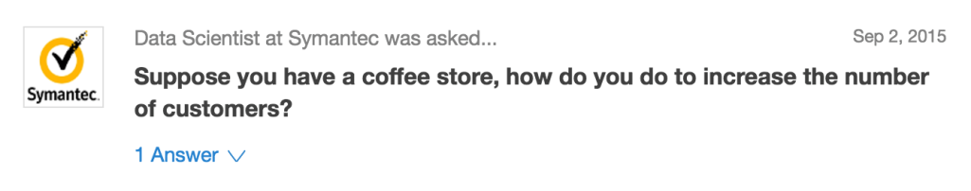

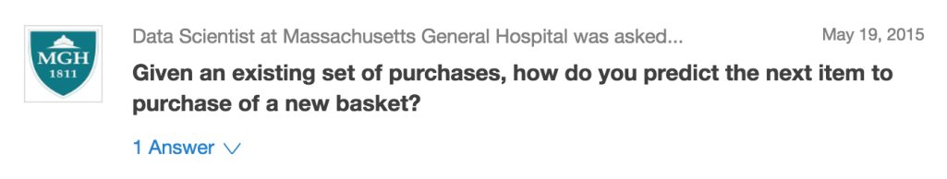

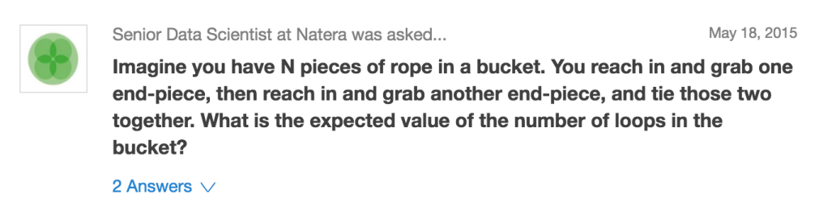

Conclusion

There is no exact formula for preparing for data science interview questions, but hopefully by reviewing these common interview questions you will be able to walk into your interviews well-practiced and confident. If you have any suggestions for questions, feel free to comment below! Good luck.

Related reading:

Our guide to [data science interviews](https://www.springboard.com/resources/data-scientist-interview-guide).

What we learned [analyzing hundreds of data science interviews](https://www.springboard.com/blog/data-science-interviews-lessons/). This also includes a selection of data science interview questions.

Sources

User-submitted interview questions from data science interview questions across the United States

[Glassdoor – Data Scientist Interview Questions](https://www.glassdoor.com/Interview/data-scientist-interview-questions-SRCH_KO0,14.htm)

Lists of general data science interview questions

[KDnuggets](http://www.kdnuggets.com/2016/02/21-data-science-interview-questions-answers.html)

[DeZyre](https://www.dezyre.com/article/100-data-science-interview-questions-and-answers-general-for-2016/184)

[Udacity](http://blog.udacity.com/2015/04/data-science-interview-questions.html)

[Data Science Central – 66 Interview Questions for Data Scientists](http://www.datasciencecentral.com/profiles/blogs/66-job-interview-questions-for-data-scientists)

[AnalyticsVidhya – 40 Interview Questions asked at Startups in Machine Learning/Data Science](https://www.analyticsvidhya.com/blog/2016/09/40-interview-questions-asked-at-startups-in-machine-learning-data-science/)

Sources for all programming and coding related data science questions

[Workable – Data Scientist Coding Interview Questions](https://resources.workable.com/data-scientist-coding-interview-questions)

[Codementor – 15 Essential Python Interview Questions](https://www.codementor.io/python/tutorial/essential-python-interview-questions)

[MaxNoy – Coding Interviews](http://maxnoy.com/interviews.html)

[DeZyre – 100 Hadoop Interview Questions and Answers](https://www.dezyre.com/article/top-100-hadoop-interview-questions-and-answers-2016/159)

Interactive tutorials for practicing Python and SQL for an interview

[Tutorials Point – Python Interview Questions](https://www.tutorialspoint.com/python/python_interview_questions.htm)

[Tutorials Point – SQL Interview Questions](https://www.tutorialspoint.com/sql/sql_interview_questions.htm)

[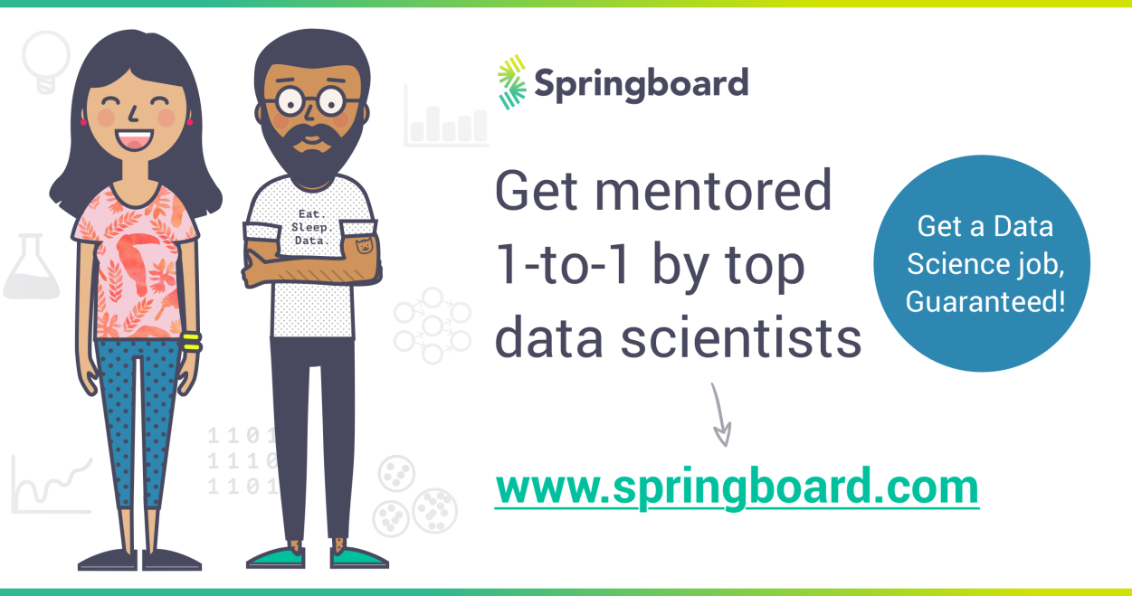](https://www.springboard.com/workshops/data-science-career-track?utm_source=blog&utm_campaign=springboardbottombanner&utm_medium=blog)

Data Science Career Track

https://secure.gravatar.com/avatar/8e881879b5ee7e2f4f2aba8f5afa642a?s=50&d=mm&r=g

Michael Rundell

Data scientist in training, avid football fan, day-dreamer, UC Davis Aggie, and opponent of the pineapple topping on pizza.

**You might also be interested in..**

[DATA SCIENCE](https://www.springboard.com/blog/category/data-science)

[19 Free Public Data Sets For Your First Data Science Project](https://www.springboard.com/blog/free-public-data-sets-data-science-project/)

Completing your first project is a major milestone on the road to becoming a data scientist. It’s also an intimidating process. The first step is to find an appropriate, interesting data set. You should decide how large and how messy a dataset you want to work with; while cleaning data is an integral part of […]

[READ MORE](https://www.springboard.com/blog/free-public-data-sets-data-science-project/)

[DATA SCIENCE](https://www.springboard.com/blog/category/data-science)

[41 Essential Machine Learning Interview Questions (with answers)](https://www.springboard.com/blog/machine-learning-interview-questions/)

Machine learning interview questions are an integral part of the data science interview and the path to becoming a data scientist, machine learning engineer or data engineer. Springboard created a free guide to data science interviews so we know exactly how they can trip candidates up! In order to help resolve that, here is a curated and […]

[READ MORE](https://www.springboard.com/blog/machine-learning-interview-questions/)

[DATA SCIENCE](https://www.springboard.com/blog/category/data-science)

[Data Science Career Paths: Different Roles in the Industry](https://www.springboard.com/blog/data-science-career-paths-different-roles-industry/)

Data Science Career Paths: Introduction We’ve just come out with the first bootcamp with a data science job guarantee to help you break into a data science career. As part of that exercise, we dove deep into the different roles within data science.  Around the world, organizations are creating more data every day, yet most are struggling […]

[READ MORE](https://www.springboard.com/blog/data-science-career-paths-different-roles-industry/)

RESOURCES

* [Free learning paths](https://www.springboard.com/resources/#learning-paths)
* [E-books and guides](https://www.springboard.com/resources/#ebooks)
* [View all resources](https://www.springboard.com/resources/)

ABOUT US

* [About the company](https://www.springboard.com/about#about-us-section)
* [Meet the team](https://www.springboard.com/about#team-section)
* [Investors](https://www.springboard.com/about#investors-section)
* [Jobs](https://www.springboard.com/join-us)

COURSES

* [Introduction to Data Science](https://www.springboard.com/workshops/data-science)
* [Intermediate Data Science: Python](https://www.springboard.com/workshops/data-science-intensive)
* [Data Science Career Track](https://www.springboard.com/workshops/data-science-career-track)
* [Business Analytics](https://www.springboard.com/workshops/analytics)
* [UX Design](https://www.springboard.com/workshops/ux-design)
* [Digital Marketing Career Track](https://www.springboard.com/workshops/marketing-career-track)
* [Introduction to Cybersecurity](https://www.springboard.com/workshops/cybersecurity)
* [Cybersecurity Career Track](https://www.springboard.com/workshops/cybersecurity-career-track/)
* [Become a mentor](https://www.springboard.com/join-us/#educators)
* [Hire our students](https://hire.springboard.com/)
* [Corporate training](https://learn.springboard.com/corporate-training/)

CONTACT US

* [Frequently Asked Questions](https://studentfaq.springboard.com/)
* [Send us an e-mail](https://www.springboard.com/contact)

  

[Like us on Facebook](https://www.facebook.com/springboard/)

[Tweet us on Twitter](https://twitter.com/springboard/)

[Read our stories on Medium](https://medium.springboard.com/)

[](https://www.springboard.com/)

Copyright 2018

[Terms](https://www.springboard.com/legal/terms) [Privacy](https://www.springboard.com/legal/privacy) [Conduct](https://www.springboard.com/legal/conduct)